PRACTICAL-01
AIM: Implementation and Time analysis of sorting algorithms. Bubble sort, Selection sort, Insertion sort, Merge sort and Quicksort
1.) BUBBLE SORT PROGRAM:
#include <iostream> using namespace std; class bubblesort { public:
int arr[100], size, i, j, temp; void getinput() { cout << "enter the size of the array:"; cin >> size; cout << "enter the elements:";
for (i = 0; i < size; i++) { cin >> arr[i];
}
}
void printelements() {
for (i = 0; i < size; i++) { cout << arr[i] << " ";
}
}
void logic() { for (i = 0; i < size - 1; i++) { for (j = 0; j < size - i - 1; j++) { if (arr[j] > arr[j + 1]) { temp = arr[j]; arr[j] = arr[j + 1];
arr[j + 1] = temp;
}
}
}
}
} ;
int main() { bubblesort bubble; bubble.getinput(); cout << "before sorting:"; bubble.printelements(); bubble.logic(); cout << "sorted elements:"; bubble.printelements(); return 0;
}
OUTPUT:
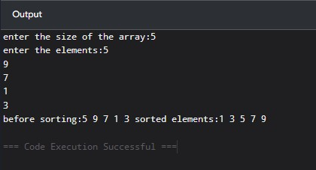
2.) SELECTION SORT:
PROGRAM:
#include <iostream> using namespace std; class selectionsort{ public:
int arr[50], size, i, j, temp, min; void getinput(){ cout<< "enter the size of the array:"; cin>> size;
cout<< "enter the elements:"; for(i = 0; i < size; i++){
cin >> arr[i];
}
}
void printelements(){ for(i = 0; i < size; i++){
cout << arr[i] << " ";
}
}
void logic(){ for(i = 0; i < size - 1; i++){ min = i;
for(j = i + 1; j < size; j++){ if(arr[j] < arr[min]){
min = j; }
}
temp = arr[i]; arr[i] = arr[min];
arr[min] = temp;
}
} };
int main(){ selectionsort selection; selection.getinput();
cout << "before sorting:"; selection.printelements(); selection.logic();
cout << "\nsorted elements:"; selection.printelements(); return 0;
}
OUTPUT:
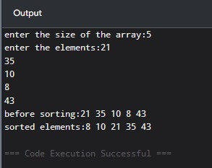
3.) INSERTION SORT:
PROGRAM:
#include <iostream> using namespace std; class insertionsort { public:
int arr[100], size, i, j, temp; void getinput() { cout << "enter the size of the array:"; cin >> size; cout << "enter the elements:";
for (i = 0; i < size; i++) { cin >> arr[i];
}
}
void printelements() {
for (i = 0; i < size; i++) { cout << arr[i] << " ";
}
}
void logic() { for (i = 1; i < size; i++) { temp = arr[i];
j = i - 1;
while (j >= 0 && arr[j] > temp) { arr[j + 1] = arr[j];
j--;
}
arr[j + 1] = temp;
}
}
};
int main() { insertionsort insertion; insertion.getinput(); cout << "before sorting:"; insertion.printelements(); insertion.logic(); cout << "sorted elements:"; insertion.printelements(); return 0;
}
OUTPUT:
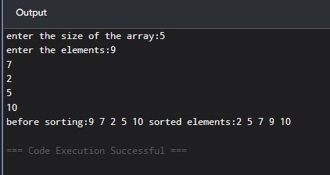
4.) QUICK SORT:
PROGRAM:
#include <stdio.h> int partition(int arr[], int lb, int ub)
{
int pivot = arr[lb]; int start = lb; int end = ub;
while (start < end)
{
while (arr[start] <= pivot)
{ start++;
}
while (arr[end] > pivot)
{ end--;
}
if (start < end)
{
int temp = arr[start]; arr[start] = arr[end]; arr[end] = temp;
}
}
int temp = arr[lb]; arr[lb] = arr[end]; arr[end] = temp;
return end;
}
void quicksort(int arr[], int lb, int ub)
{
if (lb < ub)
{
int index = partition(arr, lb, ub); quicksort(arr, lb, index - 1); quicksort(arr, index + 1, ub);
}
}
int main()
{

int arr[100], n; printf("Enter number of elements: "); scanf("%d", &n);
printf("Enter array elements: ");
for (int i = 0; i < n; i++)
{
scanf("%d", &arr[i]);
}
quicksort(arr, 0, n - 1); printf("Sorted array: "); for (int i = 0; i < n; i++)

{
printf("%d ", arr[i]);
}
return 0;
}
OUTPUT:
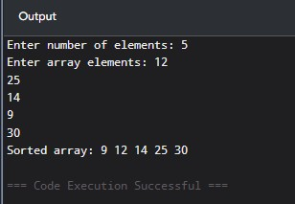
5.) MERGE SORT ALGORITHM:
PROGRAM:
#include <stdio.h>
void merge(int arr[], int lb, int mid, int ub)
{
int i = lb; int j = mid + 1; int k = lb; int b[100];
while (i <= mid && j <= ub)
{
if (arr[i] <= arr[j])
{
b[k] = arr[i];
i++; }
else {
b[k] = arr[j]; j++; }
k++;
}
while (i <= mid)
{
b[k] = arr[i]; i++;
k++;
}
while (j <= ub)
{
b[k] = arr[j]; j++; k++;
}
for (i = lb; i <= ub; i++)
{
arr[i] = b[i];
}
}
void mergesort(int arr[], int lb, int ub)
{
if (lb < ub)
{
int mid = (lb + ub) / 2;
mergesort(arr, lb, mid); mergesort(arr, mid + 1, ub);
merge(arr, lb, mid, ub);
}
}
int main()
{
int arr[100], n;
printf("Enter number of elements: "); scanf("%d", &n);
printf("Enter array elements: ");
for (int i = 0; i < n; i++)
{
scanf("%d", &arr[i]);
}
mergesort(arr, 0, n - 1);
printf("Sorted array: ");
for (int i = 0; i < n; i++)
{
printf("%d ", arr[i]);
}
return 0;
}
OUTPUT:
